# **Linux - Environment Variables**

## **What is a Computing Environment?**

Computing environment is the Platform(Platform = Operating System+ Processor) where a user can run programs.



## **What is a Variable?**

In computer science, a **variable is a location for storing a value** **which can be a** **filename**, **text**, **number** or any other **data**. It is usually referred to with its Symbolic name which is given to it while creation. The value thus stored can be displayed, deleted, edited and re-saved.

Variables play an important role in computer programming because they enable programmers to write flexible programs. As they are related to the Operating system that we work on, it is important to know some of them and how we can influence them.

## **So, what are Environment variables?**

* Dynamic values which affect the processes or programs on a computer
* Exist in every operating system; types may vary
* Can be created, edited, saved and deleted
* Gives information about the system behavior

Environment variables can change the way a software/programs behaves.

E.g. $LANG environment variable stores the value of the language that the user understands. This value is read by an application such that a Chinese user is shown a Mandarin interface while an American user is shown an English interface.

Let's study some common environment variables -

|  |  |
| --- | --- |
| **Variable** | **Description** |
| **PATH** | This variable contains a colon (:)-separated list of directories in which your system looks for executable files. Linux - Environment Variables When you enter a command on terminal, the shell looks for the command in different directories mentioned in the $PATH variable. If the command is found , it executes. Otherwise, it returns with an error 'command not found'. |
| **USER** | The username |
| **HOME** | Default path to the user's home directory |
| **EDITOR** | Path to the program which edits the content of files |
| **UID** | User's unique ID |
| **TERM** | Default terminal emulator |
| **SHELL** | Shell being used by the user |

## **Accessing Variable values**

In order to determine value of a variable , use the command

**echo $VARIABLE**

Variables are- Case Sensitive. Make sure that you type the variable name in the right letter case otherwise you may not get the desired results.

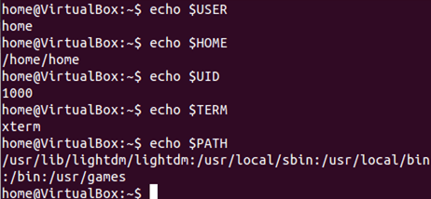

The '**env'** command displays **all the environment variables** .

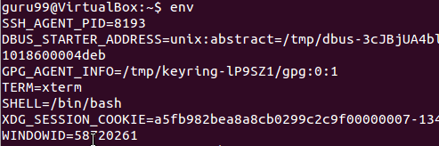

## **Creating New Variables**

You can create your own user defined variable , with syntax

**VARIABLE_NAME= variable_value**

Again, bear in mind **that variables are case-sensitive** and usually they are created in upper case.

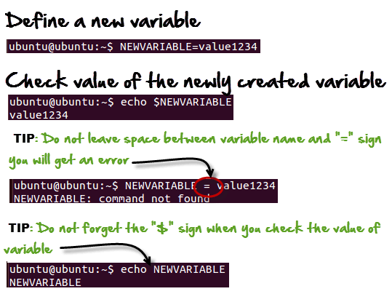

## **Deleting Variables**

The following syntax can be used to remove a Variable from the system.

**unset**

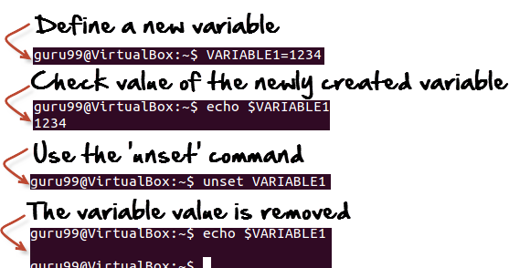

This **would remove the Variable** and its value permanently.

**Summary:**

* Environment variables govern behavior of programs in your Operating System.

|  |  |
| --- | --- |
| **Command** | **Description** |
| echo $VARIABLE | To display value of a variable |
| env | Displays all environment variables |
| VARIABLE_NAME= variable_value | Create a new variable |
| unset | Remove a variable |
| export Variable=value | To set value of an environment variable |